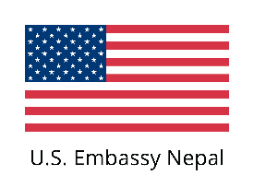 | 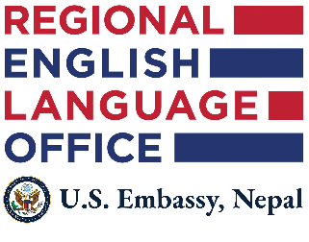 | 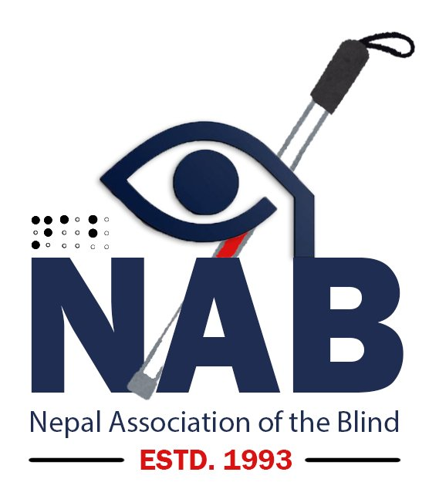

Kathmandu, Nepal • Friday, March 13, 2026
NEPAL ASSOCIATION OF THE BLIND AND U.S. EMBASSY NEPAL
LAUNCH NEPAL'S FIRST-EVER ENGLISH LANGUAGE TEACHING TRAINING
FOR BLIND AND LOW VISION TEACHERS
A Historic Milestone in Inclusive Education Across Nepal

The Nepal Association of the Blind (NAB), in partnership with the Regional English Language Office (RELO) of the U.S. Embassy Nepal, today inaugurated a landmark five-day English Language Teaching (ELT) Training for Blind and Low Vision Teachers — the first of its kind ever conducted in Nepal. The training commenced on Thursday, March 12, 2026, at Maya Manor Boutique Hotel, Hattisar, Kathmandu, and runs through March 16, 2026.
About the Training
This groundbreaking training brings together 25 teachers with visual impairments — 20 totally blind and 5 with low vision — drawn from 18 districts spanning six provinces of Nepal. The participant group comprises 16 male and 9 female educators teaching at the primary, lower secondary, and secondary levels of Nepal's national education system.
The programme equips Blind and Low Vision English language teachers with evidence-based English Language Training (ELT) methodologies, adaptive classroom strategies, and inclusive assistive technology tools — enabling them to deliver high-quality English instruction to all learners, both sighted and visually impaired.
Programme Highlights
The five-day training curriculum covers:
- Principles of English Language Teaching adapted for visually impaired learners
- Modifying instruction: vocabulary, reading, listening, and speaking strategies
- Communicative Language Teaching (CLT) and Task-Based Language Teaching (TBLT)
- Accessible document creation using Microsoft Word and assistive digital tools
- AI-powered tools for education: Google Gemini and NotebookLM for lesson preparation
- Converting inaccessible PDFs, images, and print materials into accessible digital formats
- Micro-teaching practice with structured peer observation and facilitator feedback
- Confidence-building strategies and professional development goal setting

Participant Profile

Total Participants | 25 Blind and Low Vision Teachers
Gender Distribution | 16 Male | 9 Female
Vision Status | 20 Totally Blind | 5 Low Vision
Geographic Coverage | 18 Districts across 6 Provinces of Nepal
Teaching Levels | Primary, Lower Secondary, and Secondary

Training Team
The training is delivered by a distinguished team of practitioners and specialists:
Professor Madeline Milian: Lead Trainer — internationally recognized expert in visual impairment and English Language Teaching
Mr. Khomraj Sharma: Co-Trainer and Project Coordinator, NAB — Assistive Technology Trainer and Inclusion Advisor
Mr. Krishna Acharya: ICT Instructor — specialist in assistive technology and accessible digital content creation
Mr. Roger Cohen: Regional English Language Officer, RELO / U.S. Embassy Nepal
Mr. Bishwa Gautam: English Language Programs Specialist, RELO / U.S. Embassy Nepal
Significance and Impact
This training marks a defining moment in Nepal's journey toward truly inclusive education. For the first time, visually impaired English language teachers are receiving professionally structured, internationally guided professional development that directly addresses the pedagogical and technological realities of teaching English in BLV contexts.
Nepal's Blind and Low Vision teachers have long navigated the dual challenge of teaching English — a subject critical to social and economic participation — without access to tailored professional support. This initiative, facilitated through the strong partnership between NAB and RELO/U.S. Embassy Nepal, addresses those long-standing gaps in a meaningful and sustainable way.
“This training is not just a professional development programme — it is a statement of equity. When blind and low vision teachers are equipped with the best pedagogical tools available, their students benefit directly. We are proud to deliver this, and deeply grateful to our partners at RELO and the U.S. Embassy for making it possible.”
— Khomraj Sharma, Information Officer, Nepal Association of the Blind
About Nepal Association of the Blind (NAB)
Established in 1993, the Nepal Association of the Blind (NAB) is the national apex organization representing blind and low-vision persons across Nepal. Based in Sukedhara-04, Kathmandu, NAB leads national advocacy, inclusive education, assistive technology training, and capacity-building programs for Blind and Low-Vision individuals throughout all seven provinces of Nepal. NAB operates aankha.nabnepal.org, Nepal's premier accessible digital library for visually impaired users.

About RELO / U.S. Embassy Nepal
The Regional English Language Office (RELO) at the U.S. Embassy Nepal supports English language teaching and learning across Nepal and the South Asia region. RELO provides professional development resources, teacher training programmes, and access to U.S. educational expertise to strengthen Nepal's English language education community.

FOR MEDIA INQUIRIES AND FURTHER INFORMATION:
Khomraj Sharma
Information Officer | Assistive Technology Trainer & Project Coordinator
Nepal Association of the Blind (NAB)
Sukedhara, Kathmandu, Nepal
Email: info@nabnepal.org| Website: www.nabnepal.org
Telephone: +977-1-4376598

____________________________
Khomraj Sharma
Information Officer
Nepal Association of the Blind (NAB)
Date: March 12, 2026
— END —
Nepal Association of the Blind (NAB) • Sukedhara, Kathmandu • www.nabnepal.org

